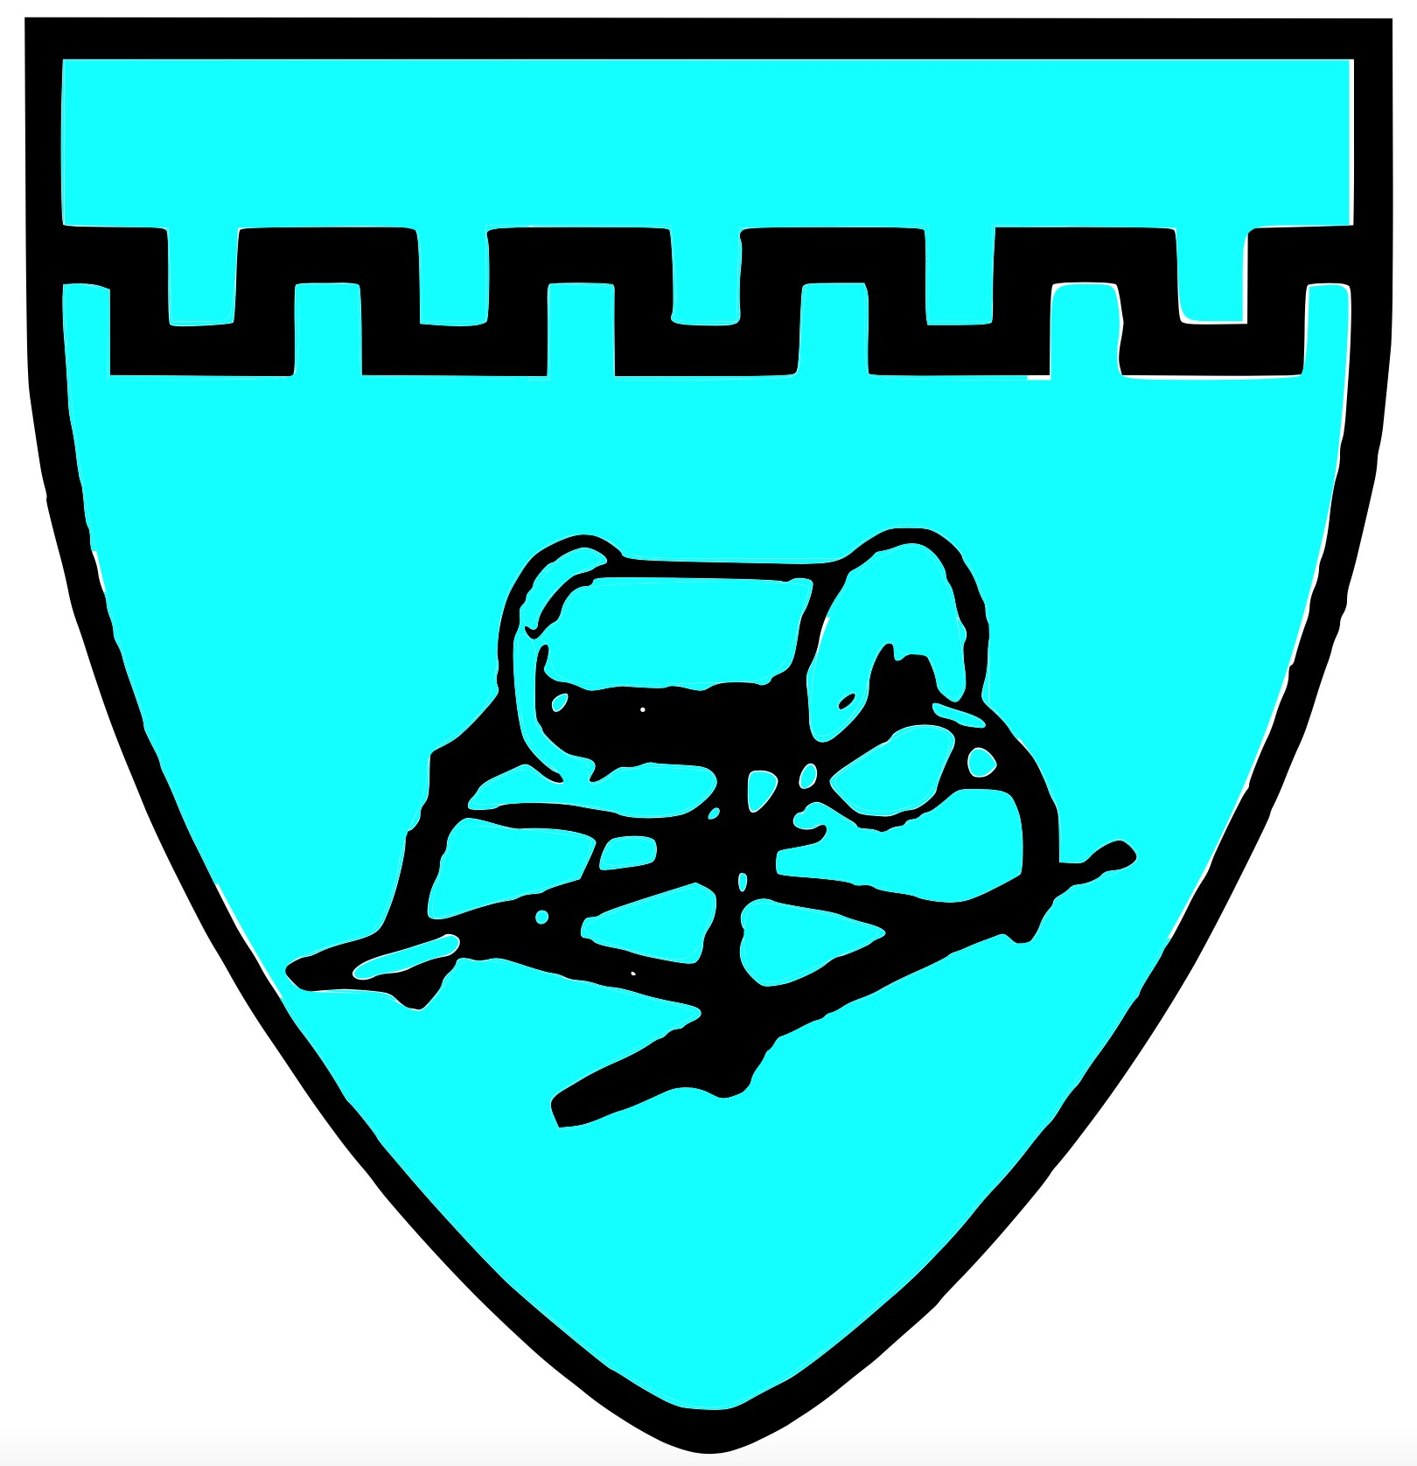

**Chiton Rocks SLSC** Position Description

**Chief Instructor**

The Chief Instructor has the overall responsibility for the coordination and delivery of the Club’s Surf Life Saving training programs and is a member of the Board of Management.

Key Responsibilities:

* Identify training needs and develop training plans whilst liaising with, trainers, assessors and advisors
* Liaise with and support the trainers of each area: -Surf Life Saving Certificate, Bronze Medallion, Inflatable Rescue Boat and Advanced Resuscitation Techniques Certificate
* Ensure that all active members are proficient and maintain a record of Skills Maintenance
* Be responsible for all administration of Club assessments
* Seek expressions of interest of members wishing to gain SLS awards
* Liaise with the Member Education Officer Surf Life Saving SA to ensure that all members training for awards are registered
* Be responsible for the submission of the appropriate paperwork or entering into Surfguard the necessary information for Assessments and Skills Maintenance
* Ensure appropriate water safety risk assessments are completed for all training, proficiencies and assessments
* Keep up to date with current systems & processes
* Have a level of understanding of the SLSA/SLSSA award structure
* Have a level of skill and understanding outlined within the SLSA/SLSSA training procedures
* Attend monthly board meetings via Zoom and/or face to face meetings.

Key Attributes:

* Good organisational skills
* Computer skills
* Good communication and interpersonal skills

All Board of Management positions hold equal responsibility in the governance and compliance of the club.