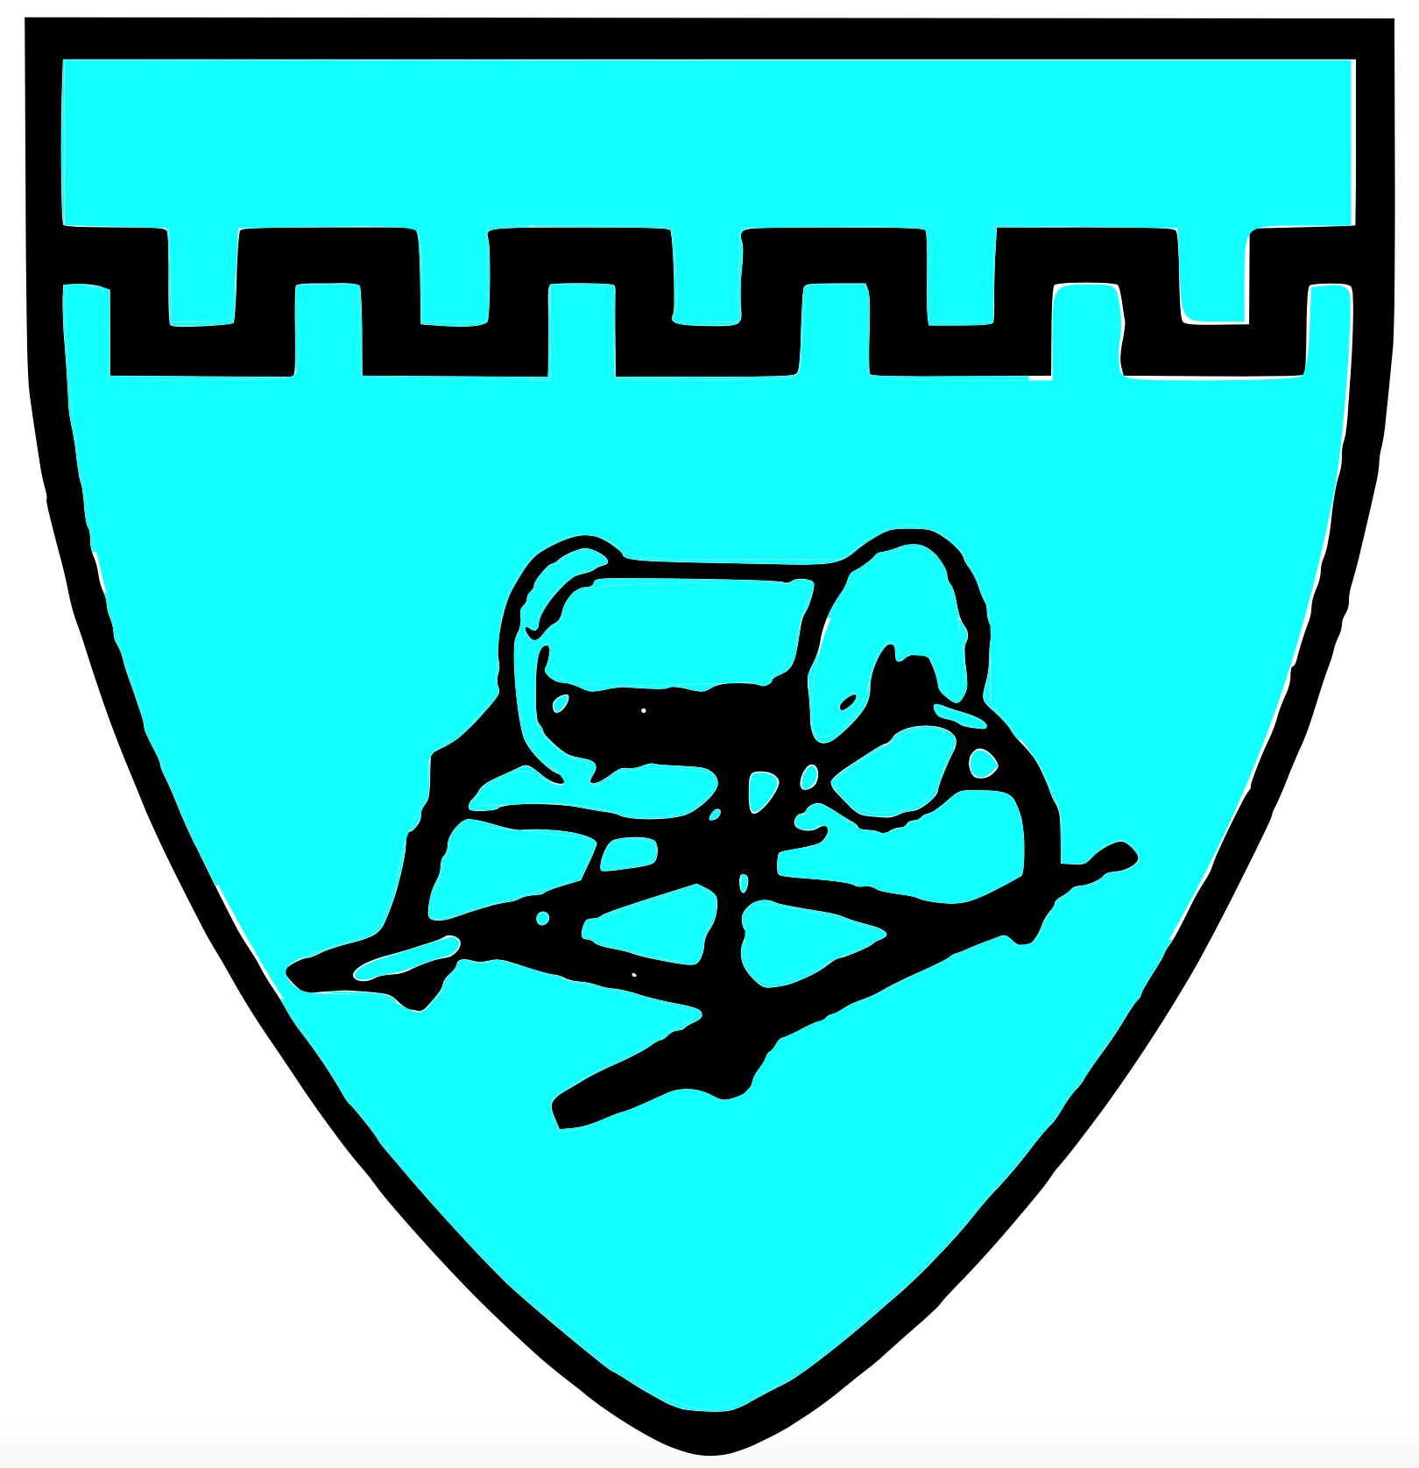

**Chiton Rocks SLSC** Position Description

**Club Captain**

This is an Executive Board of Management position and will be responsible for all Surf Life Saving operations at the club and ensure members are suitably qualified and proficient at that club equipment is suitably maintained.

Key Responsibilities:

* Administer and organise beach patrols ensuring rosters have appropriate levels of experience and qualifications
* Manage adherence to LSA and SOP – quality assurance
* Coordinate pre-season preparation including equipment, uniforms, award upskilling
* Liaise with Chief Instructor to address patrol requirements,
* Ensure all patrol data is entered into Surfguard promptly
* Keep records of members patrol duties and performance
* Oversee annual gear and equipment inspections
* Liaise with Vice President regarding grants and equipment required
* Attend SLSSA meetings as required
* Attend monthly board meetings via Zoom and/or face to face meetings.

Key Attributes:

* Current Bronze Medallion and Silver Medallion in Beach Management
* Good understanding of club culture and lifesaving operations
* Good Communication and interpersonal skills with positive attitude
* Ability to organise and delegate tasks
* High Level of confidentiality of relevant matters
* Good Computer skills

Liaise with Vice-Captain on matters relating to beach safety.

All Board of Management positions hold equal responsibility in the governance and compliance of the club.