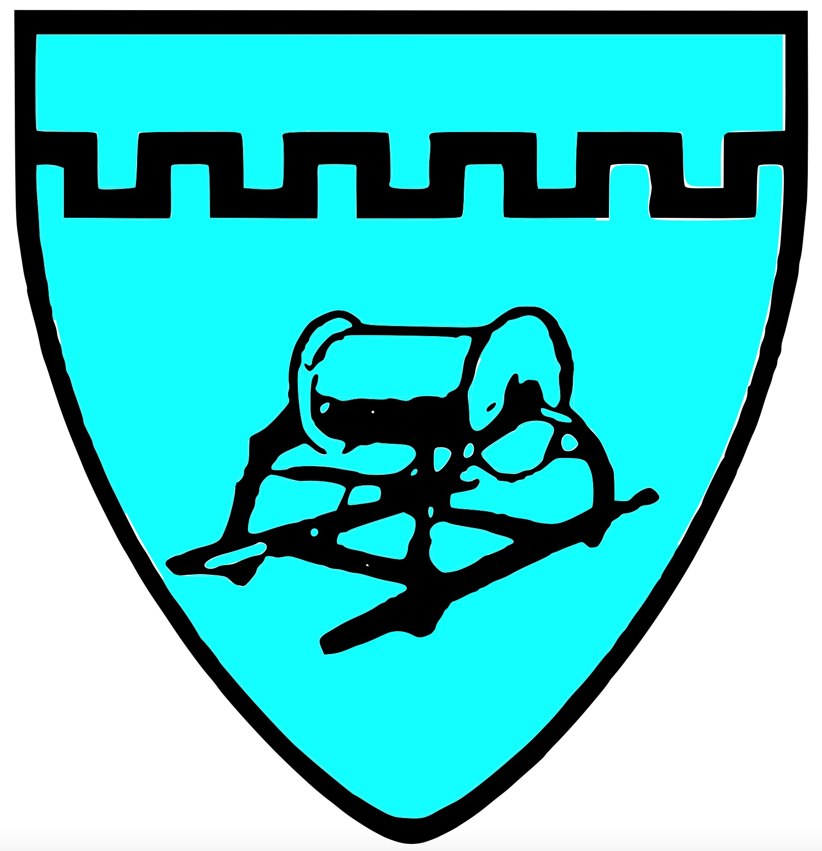

**Chiton Rocks SLSC** Position Description

**President**

The President has the overall responsibility for governance and compliance of the Chiton Rocks SLSC and is Chair of the Board of Management (BOM).

Key Responsibilities:

* Chair the BOM and Executive Committee
* Responsible for Strategic Plan & 5 Year Goal planning
* Responsible for Health Safety Environment of the club and its members
* Represent the Club at major external meetings & forums ensuring the objects, vision, purpose & interests of the club, SLSSA & SLSA are considered at all times.
* Motivate and lead by example regarding positive club culture

Specific Duties include but are not limited to:

* Manage the ongoing development of the strategic plan
* Ensure all SLSA/SLSSA policies and guidelines are being followed
* Attend SLSSA State Council monthly meetings and as required
* Understand the club’s financial position and goals.
* Approve all club communication to members prior to distribution
* Monitor security and safety of club facilities
* Have access to Security CCTV
* Have a good working knowledge of club’s governance, constitution and policies
* Provide leadership and continuous support to members to ensure the club is a safe environment for
* Mediate and enforce disciplinary action when needed
* Be a signatory for the Club in all legal and financial purposes
* Serve as a spokesperson for the club when required

Key Attributes:

* High Level interpersonal and communication skills
* High Level organisational skills
* Be forward thinking but with a good knowledge of the club’s history
* Ability to speak public publicly and represent the club respectfully

All Board of Management positions hold equal responsibility in the governance and compliance of the club.